**Acknowledgement**

We are extremely thankful to Prof. M.R Dhage for her expert guidance and continuous encouragement throughout to see that adequate research has been conducted to approve the project. Collectively, we would also like to thank our project committee members Prof. E. Jayanthi and Prof. A.S. Kalaskar for their time, suggestions, and for graciously agreeing to be on our committee, and always making themselves avail- able. We would like to express deepest appreciation towards Prof. M. P. Wankhade, Head of Department of Computer Engineering, Dr. S. D. Lokhande, Principal, Sinhgad College Of Engineering**.**

**Abstract**

IoT devices are becoming popular day-by-day. Several vulnerabilities in IoT present the need for IoT security. The number of attacks on these devices keep increasing and most of them are slight variations of the previously known attacks, which can bypass the conventional firewall systems.

The existing systems are not suitable for IOT devices as IOT devices have low computational power. Those that use signature-based intrusion detection. It works only on known patterns and attacks, hence they cannot recognize newer attacks with unknown pattern. Also, many systems use cloud computing, which has a downfall that it needs access to internet at all times, also the cloud services are most often paid.

In the proposed system, we are planning to use anomaly-based detection system. The anomaly-based intrusion detection system comes into effect when detecting newer attacks, that are not filtered by the firewall. It is capable of handling newer/unknown attacks, which signature based cannot. Also we are setting up the IDS on a local higher powered device rather than on cloud. Machine learning ensemble model Random forest is used. The model will be trained on the DS2OS traffic traces dataset.

**Chapter 1**

**Introduction**

**1.1 Background and Basics**

Internet of things, or IoT, is a system of interrelated ”things ” that are provided with unique identifiers and the ability to transfer data over a network without requiring human-to-human or human-to-computer interaction. These ”things” could be com- puting devices, mechanical and digital machines such as build in sensors, monitors etc.

A good example of a network of IoT devices is the security system implemented by various locations which include, CCTV cameras, motion sensors, automatic locks, smoke detectors, temperature sensors etc.

IOT devices are becoming pervasive. They are used extensively in a lot of fields and their utility is just going to keep increasing. IOT devices help to automate things, reduce labour costs and facilitate smart living.

Hence, it is important to build an optimal system that can provide proper safety and security measures for IOT devices.

An intrusion detection system is one such system that can be a building block in making the IOT network as secure as possible. An intrusion detection system is a system that passively monitors the data exchange in the network and of the network with externals entities and looks for malicious activities that can be classified as an intrusion or attack. It then notifies the user or sends a notification to some other system which may or may not take action against the detected intruder. Simply put, if the network of devices is a home, an intrusion detection system is a CCTV camera.

Also, a step up from just a intrusion detection system is an anomaly based intrusion detection system. This type of system creates a profile of normal behaviour, and any activity that falls outside of the normal category is marked as anomalous. Anomaly based system is better suited to defend the system against zero-day attacks.

There are certain challenges while building this system which are specific to IOT devices. For example, the low computational powers and limited amount of resources (such as space/memory). The IDS system should be build keeping in mind all these challenges and they should be overcome in the most efficient manner.

**1.2 Literature Survey**

**Table 1.1: Literature Survey**

|  |  |  |  |  |  |  |  |
| --- | --- | --- | --- | --- | --- | --- | --- |
| Title | Year | Publication | Data -set | HIDS /NIDS | Anomaly /Signa- ture | Model used | Drawbacks |
| Anomaly based intrusion de- tection system through feature selection analy- sis and building hybrid efficient model | 2018 | Journal of computational science 25(2018) 152-160 | NSL- KDD | NIDS | Anomaly | Hybrid | Not imple- mented for iot Devices |
| Distributed at-  tack scheme deep approach for Internet of Things  detection using learning | 2017 | Future Genera- tion Computer Systems (2017) | NSL- KDD | NIDS, fog | Signature | Deep learning | signature based, new attacks cannot be recog- nized |
| Towards Ma- chine Learning Based IoT Intru- sion Detection Service | 2018 | Springer In- ternational Publishing AG, part of Springer Nature 2018 | UNSW-NB15 | NIDS,Cloud | Anomaly | Neural net- work, random forest | uses cloud com- puting, which increases the resource require- ments |
| Host based intrusion de- tection system with combined CNN/RNN model | 2019 | Springer Na- ture Switzer- land AG 2019 | ADFA- LD | HIDS | Anomaly | RNN with GRU | HIDS, and not NIDS Perfor- mance doesnt match ensemble models |
| Anomaly-based intrusion detec- tion of iot device sensor data us- ing provenance graphs | 2018 | 1st Inter- national Workshop on Security and Privacy for the Internet- of-Things (IoTSec) | longi -tudinal data on the thermal | HIDS | Anomaly | Prov -enance graphs | Works with offline data, doesnt work with real time data |

.

**1.3 Project Undertaken**

**1.3.1 Problem Definition**

Design and implement an anomaly Based Intrusion Detection System in IoT Networks using Random Forest which will passively monitor the IoT network traffic and alerts the user for any intrusion detected.

**1.3.2 Scope Statement**

Product can be used in any IOT network for the purpose of the security. Since use of IOT devices is increasing, day by day, in all fields and sector, there is an increasing need for security mechanisms designed specifically for IOT devices or networks. The main function of the IDS system is to detect anomalous behavior that can be caused by the attacks. So it can be deployed anywhere where we need security measures in place to protect IOT devices.

**1.4 Organization Of the Project Report**

The project report is organized as follows:-

**1.4.1 Chapter 1**

Chapter 1 is Introduction. It gives the background and basics of the project. It is followed by a detailed literature survey of similar works in the past. Problem statement and scope of the project are defined as well.

**1.4.2 Chapter 2**

Chapter 2 is Project Planning and Management. It has details of the system requirement specifications which include functional and non-functional requirements, system overview, deployment environment, external interface and other requirements. The project process model applicable to this project is also mentioned. Cost estimate analysis and time line scheduling is done as well.

**1.4.3 Chapter 3**

Chapter 3 is Analysis and Design. It consists of idea matrix, mathematical model and feasibility analysis. All the analytical and design diagrams are also included in this chapter. These diagrams include use case diagram, activity diagram, architecture diagram, class diagram, ER diagram, sequence diagram, state transition diagram and deployment diagram.

**1.4.4 Chapter 4**

Chapter 4 is Testing. In this chapter, test cases regarding different types of testing are given. The types of testing included are unit testing, integration testing and acceptance testing.

**Chapter 2**

**Project Planning and Management**

**2.1 Detail System Requirement Specification**

**2.1.1 System Overview**

**Product Perspective**

The system has been inspired by the already existing intrusion detection systems which attempt to protect the home-network against attacks and intrusions. We are taking these pre-existing models and combining them to get additional advantages and reduce the downsides as much as possible. Till date, there have been very few attempts at making an IDS for IOT devices. Most of the IDS present in the market cater to non-IDS networks. We are taking the principles of these IDS systems and modifying them as per requirement of an IOT network.

**Product Functions**

1) User authentication  
2) Data connection establishment 3) Intrusion detection analysis  
4) Notification

**User Classes and Characteristics**

Factories and companies employing a network of IOT devices. Usually the IOT net- works for these users are larger and require higher level security systems as economic factors are involved. Residential habitants employing network of IOT devices. Includes home-IOT networks (smart homes), or residential society IOT networks like CCTVs, smoke detectors, fire alarms etc. These networks are usually smaller than the previous.

**Operating Environment**

The system will be implemented on Windows. Python is used for programming the backend using Django Framework. Languages such as Python and MySQL and platform like XAMPP are used for database and connection. Libraries like sklearn, pandas etc. will be used. For real life implementation, IOT data will be connected from Wireshark.

**Design and Implementation Constraints**

• The user will be notified through a web app, which should be installed on his system.

• All the nodes of the IOT network should be connected to the main server where the processing is to take place.

• The device to be notified also has to be part of the given network. • Processing time should be as low as possible.  
• Backend should be connected to database.  
• Zigbee(IEEE 802.15.4) supported on all the IOT devices.

• Server has an Zigbee adapter. User Documentation

• User manual.

**Assumptions and Dependencies**

• We are assuming that the machine has the required resources (memory and pro- cessing power etc.) and capabilities to run the system.

• The user has updated system.  
 We are assuming that the system has the required packages and dependencies (such as Django and Xampp or SQL) to run the system.

**2.1.2 External Interface Requirements**

**User Interfaces**

1)User login page  
 Username  
 Password  
 Login(Button)  
2)User Notification page Notifies when the network is under attack or some anomalous activity is detected.

**Hardware Interfaces**

Hardware interfaces for a web application will run only on windows. Other applica- tions can be created on other operating system like Apples IOS, Linux, Android, etc. For connection of IOT nodes to the main server will require a network. For a larger model, the network and servers will increase. IOT nodes are embedded with Arduino microcontroller which uses Zigbee protocol (IEEE 802.15.4). The main servers needs to be fitted with a Zigbee adapter to enable data transfer from IOT nodes.

**Software Interfaces**

1)Operating system-We have chosen Windows operating system because of its user friendly features, benefits of security and control without complexity and unrealistic costs.  
2)Database-Mysql database using Xampp.

3)Python-To program and implement the backend. The web application is connected to the backend which is on the network server. The server is connected to all the IOT nodes of that networks. These nodes transfer data to this server. The backend then processes this data to detect abnormal behavior.

**Communications Interfaces**

1)Web application runs on a web browser  
2)HTTP is used for notification system  
3)Zigbee (IEEE 802.15.4) is used for data transfer from IOT nodes to the server.

**2.1.3 System Features**

**Sensing of the data using IOT sensor**

**Description and Priority**

First, sensors or devices collect data from their environment. The benefit of this feature is much larger and the cost of this feature is reasonably low. Only risk of this feature is that it sometimes may not work as intended.

**Stimulus/Response Sequences**

Once the IOT device is started it generates a constant stream of data which is sent to the network server. Based on this data, an intrusion or attack can be detected.

**Functional Requirements**

IOT sensor nodes equipped with Arduino.

**Connectivity**

**Description and Priority**

The sensors/devices is be connected to the network through Zigbee protocol. This feature is of high priority because the sensed data needs to be processed further. The data will be processed only if it gets proper way to reach to the server. Only risk of this feature is that it can sometimes not send the data to the server.

**Stimulus/Response Sequences**

Data sensed is sent to the server.

**Functional Requirements**

Main server of the network along with ZigBee adapter.

**Data Processing**

**Description and Priority**

Once the data gets to the server, software performs processing on it. Here IDS software is used to determine the category of the attack. This feature is of high priority because this is the main objective behind selecting this project. Only risk of this feature is that it can sometimes not categorize the attack perfectly.

**Stimulus/Response Sequences**

In response, it will determine whether the attack was normal or malicious.

**Functional Requirements**

IDS software.

**User interface**

**Description and Priority**

Next, the information is made useful to the end-user in some way. This is an alert to the user (text, notification, etc.). This feature is of medium priority. Only risk of this feature is that it can sometimes not work as intended.

**Stimulus/Response Sequences**

In response it will give notification of the attack on the GUI.

**Functional Requirements**

GUI

**2.1.4 Non- Functional Requirements Performance Requirements**

The data transfer from the IOT nodes to the main server should take as little time as possible for proper real time functioning of the system. Also, the processing of the data should be fast enough so as to give proper result as soon as the attack happens, i.e. the time between the occurrence and detection of the attack should be minimum.

**Safety Requirements**

The backend could crash resulting in failure of the whole system. If the system takes up all the processing power, that machine could crash. Regular maintenance of the networking components, such as checking the proper functioning of the Arduino and Zigbee adapter should be done.

**Security Requirements**

User need to login to get access to the system, in this case users data should be protected. Systems should be secure against unauthorized access to any of their data, unauthorized use of them or any of their components. Details regarding IOT devices and their data should also be protected.

**Software Quality Attributes**

Our software has many quality attribute that are given below: -

* Availability: This software is freely available to all users. The availability of the software is easy for everyone.
* Maintainability: After the deployment of the project if any error occurs then it can be easily maintained by the software developer.
* Reliability: The performance of the software is better which will increase the reliability of the Software.
* User Friendly: Since, the software is a GUI application, the output generated is much user friendly in its behaviour.
* Integrity: Integrity refers to the extent to which access to software or data by unauthorized persons can be controlled.
* Security: Users are authenticated using many security phases so reliable security is provided.

**2.1.5 Other Requirements**

1)Configuration- -Systems should be configurable for detection and reaction, as feasible for alerts, updates, protocol and port coverage, and detection-threshold levels -Systems should be configurable treat identified IP or other network addresses exceptionally; for example, configurable to never block or shun network activity from one or more IP addresses.

2)System Updates-These capabilities should be engineered in such a manner as to allow updates during operational use of the products without disruption.  
3)Ease of use-Operator console should not require undue expertise to operate; experts may reside external to operator staff, experts may reside external to operator stuff.

**2.2 Project Process Modelling**

Iterative waterfall model is the best suited for this project. Iterative waterfall model can be thought of as incorporating the necessary changes to the classical waterfall model to make it usable in practical software development projects. It is almost same as the classical waterfall model except some changes are made to increase the efficiency of the software development.

The iterative waterfall model provides feedback paths from every phase to its preceding phases, which is the main difference from the classical waterfall model. In our project, every phase is well defined and to be executed one after the other sequentially, like the waterfall model. But if need be, there is space for going back to previous stages making changes. Hence, iterative waterfall is to be used for this project.

**2.3 Cost Efforts Estimates**

As per the basic COCOMO cost estimation formula projected cost for our product, Development Effort = a1 x (KLOC)a2PM  
= 2.4 * (4)1.05 = 10 Person Months(approx.)

Nominal development time=b1 x (Effort)b2 Months = 2.5 * (10)0.38 = 6 months(approx.)

Cost required to develop the product = NDT x Average salary per month x members

=6 * 5000 * 4  
=Rs 120,000/-  
Where, KLOC is the estimated size of the software product expressed in Kilo Lines of Code  
a1, a2, b1, b2 are constants for each category of software products.

**2.4 Project Scheduling Time Line Chart**

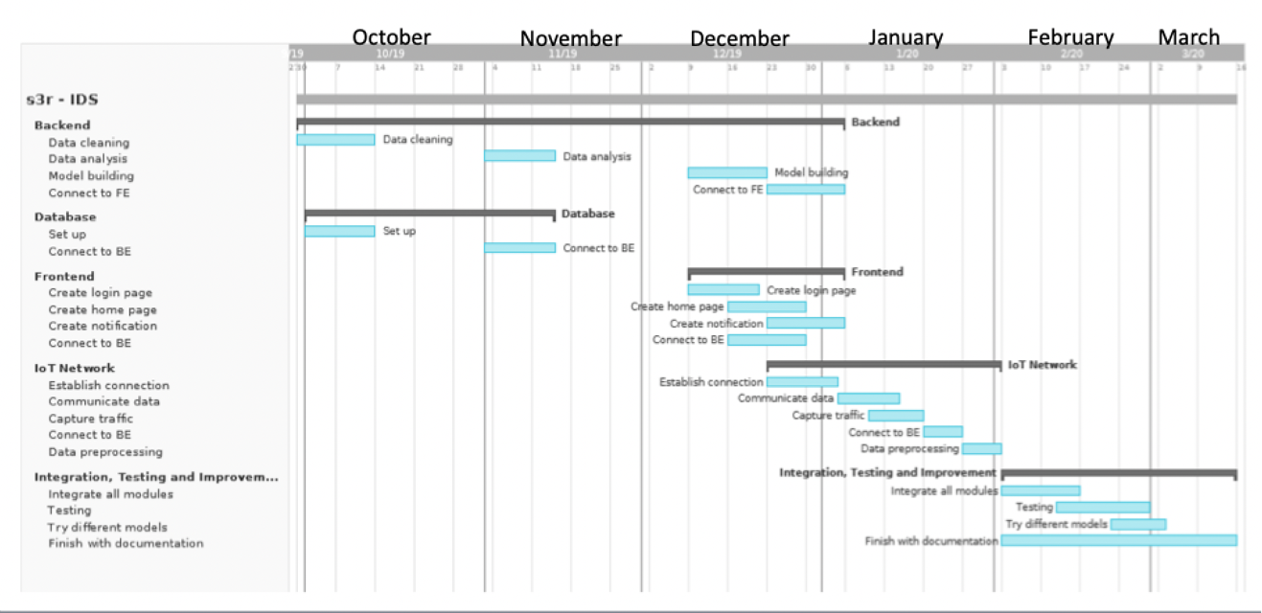

**Figure 2.1: Time Line Chart**

**Chapter 3**

**Analysis Design**

**3.1 IDEA matrix**

**Table 3.1: Idea Matrix**

|  |  |  |
| --- | --- | --- |
| Idea Matrix | | |
| Increase | 1)It increases Network security  2)It increases network monitoring | 1)Network security  2) Network monitoring |
| Improve | 1)It improves zero-day attack detection  2)Improves IoT security  3) Improves awareness of user about network intrusions | 1)Unknown attacks  2)IoT security  3) User awareness |
| Ignore | 1)It ignores the normal behavior in the network | 1)Normal behavior |
| Deliver | 1)It delivers efficient intrusion detection system for IoT devices | 1)IoT security |
| Document | 1)Documentation of the project for researchers to understand and improve on the project in the future. | 1)Project documentation |
| Decrease | 1)It decreases efforts taken to create signatures | 1)Effort |
| Educate | 1) Educate project members with security concepts, machine learning, MySQL, Wire- shark  2) Educate user | 1)Project members  2)User |
| Evaluate | 1)Continuously monitor network traffic for intrusions  2)Evaluate packets to determine if there is an intrusion | 1)Network Traffic  2)Packets |
| Experiment | 1)Experiment on different types of attacks  2) Experiment on different types of ML models | 1)Attacks  2)ML Models |
| Accelerate | 1)It increases the processing speed by using a separate device instead of the IoT device itself | 1)Processing speed |
| Analysis | 1)It analyses detected anomalies to deter- mine what type of attack it is | 1)Category of attack |
| Advertise | 1)Advertise about IoT security and need of an IDS  2)Create a GitHub page, which will include code, documentation and process | 1)Security awareness  2) GitHub |

**3.2 Mathematical Model**

Let S be the solution set for the given problem statement.

S={Input,Function,Output, Terminate,Success,Failure}.

Where,Input =Input to the System.  
Function =Functions of the system.

Output =Output of the system.  
Terminate= Terminating Condition of the System. Success =Success cases for the System.  
Failure =Failure cases for the system.

1. Input ={UserName,Password,Data Packets}

a. UserName :-use rid

b. Password : user passsword

c. Data Packets:- A data packet is a unit of data made into a single package that travels along a given network path.

2. Function={Login auth,Network connection,train test,intrusion detection,Notification}

a. Login auth: This function will take Username and Password as the input and gives  
the authorization rights to the user accordingly.

IF Y=F(X) is the login auth function then  
X: - Username and Password taken as an input.

Y: - Authorization rights of a user.

b. Network connection =This function will take port number, ip address as an input to give the status of the connection network.

IF Y=F(X) is the Network Connection Function, then

X:- Inputs to setup a network, connecting to a device ,routing the incoming data and device configuration.

Y:- Status of the network connection.

c. train test: This function will take features as an input to give the accuracy of the model and further it will be turned to improve the accuracy of the model. Ran- dom Forest has been used as a Machine learning algorithm for building the model.

IF Y=F(X) is the function to test and train the model then,

X:- Features of the DS2OS dataset as an input.  
Y:- Accuracy of the model

d. intrusion detection : This function will take features like sourceID, sourceAddress, sourceType, sourceLocation, destinationServiceAddress, destinationServiceType, des- tinationLocation, accessedNodeAddress, accessedNodeType, operation, value, times- tamp as an input and notifies the user the system for the intrusion.

• Random Forest Classifier has been used for the building and implementing the model.

Basically, a random forest is an average of tree estimators. As with nonparametric regression, simple and interpretable classifiers can be derived by partitioning the range of X.

Le tn=A1,. . . ,AN be a partition of X. Let Aj be the partition element that contains x. Then h(x) = 1 if XiAj Yi XiAj (1 Yi) and h(x) = 0 otherwise.

We conclude that the corresponding classification risk satisfies R(h) R(h) = O(n1/(d+2)).

Trees are useful for their simplicity and interpretability. But the prediction error can be reduced by combining many trees.

These are bagged trees except that we also choose random subsets of features for each tree. The estimator can be written as

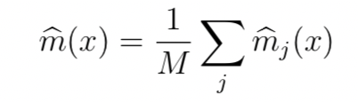

where mj is a tree estimator based on a subsample (or bootstrap) of size a using p randomly selected features. The trees are usually required to have some number k of observations in the leaves. There are three tuning parameters: a, p and k. You could also think of M as a tuning parameter but generally we can think of M as tending to . For each tree, we can estimate the prediction error on the un-used data. (The tree is built on a subsample.) Averaging these prediction errors gives an estimate called the out-of-bag error estimate.

IF Y=F(X) is the function then,

X: sourceID, sourceAddress, sourceType, sourceLocation, destinationServiceAd- dress, destinationServiceType, destinationLocation, accessedNodeAddress, accessedNode- Type, operation, value, timestamp as an input

Y: Notifies the system.

e. Notification: This function takes the input which is provided by the function (intrusion detection) and notifies the user.

IF Y=F(X) is the function then,

X: Output of the function(intrusion detection).

Y: Intrusion message to the user.

3. Output = {display intrusionmsg }  
a. display intrusionmsg : display error message if any intrusion occurs.

4. Intermediate Results  
a. Successful working of module.  
b. Successful Working of Network.  
c. Successful User authentication.  
5. Terminate= {Invalid details, Network failure, Timeout } a. Invalid User Authentication.  
b. Network failure  
c. timeout

6. Success  
a. Successful user login.  
b. Successful connection establishment of nodes and ids. c. Successful detection of intrusion.  
d. Displaying the results.  
e. Appropriate error messages in case of invalid input.

7. Failure  
a. Web app Failure.

b. Hardware faults.  
c. Network establishment failure.

d. Not displaying required results.

**3.3 Feasibility Analysis (NP Completeness Analysis)**

The problem is to detect an intrusion in a Iot network. The main objective of our project is to provide a real-time solution for any possible intrusions.

In the proposed system, we are planning to use anomaly-based detection system. The anomaly-based intrusion detection system comes into effect when detecting newer attacks, that are not filtered by the firewall. Random Forest is an ensemble model of decision trees.

Training Complexity: O((n2)pntrees)

Prediction Complexity: O(pntrees)

Calling n the number of training sample, p the number of features, ntrees the number of trees (for methods based on various trees),  
where,  
n= 21000 (Approx.)

p = 17

ntress= 4

Hence O(pntrees) runs in polynomial time complexity.

The algorithm falls in P. Hence, the given problem is NP.

**3.4 Use-Case Diagrams**

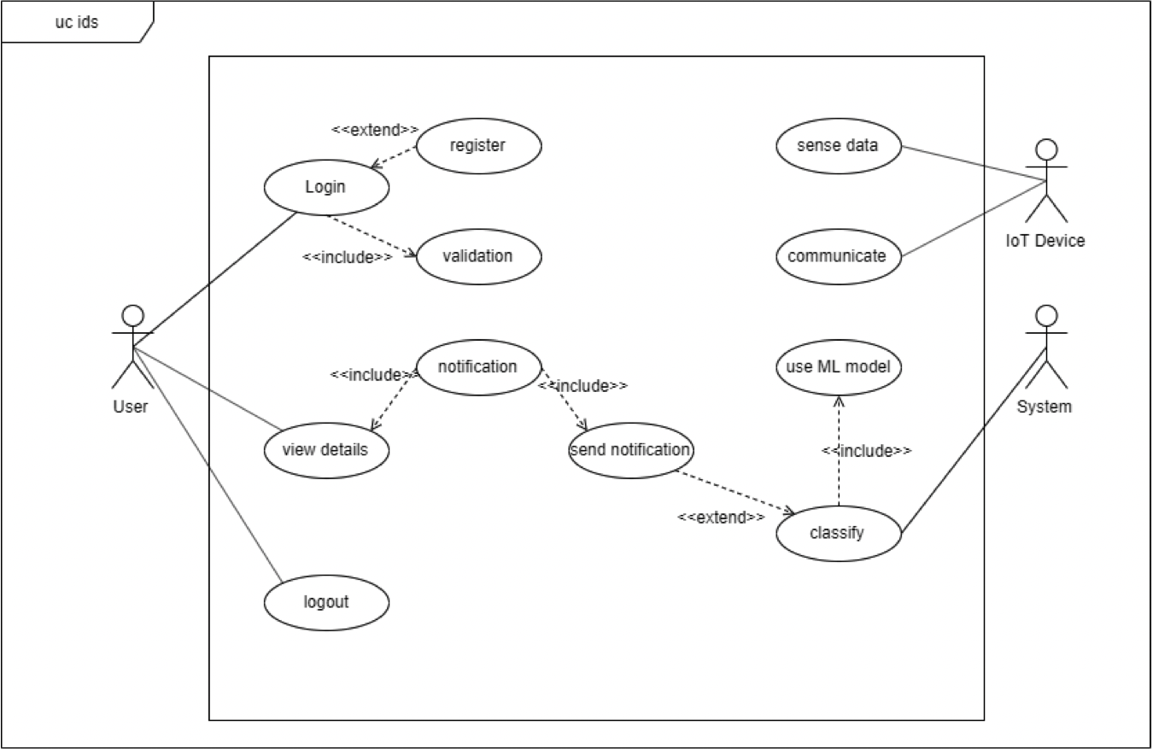

**Figure 3.1: Use-case Diagram**

**3.5 Activity Diagram**

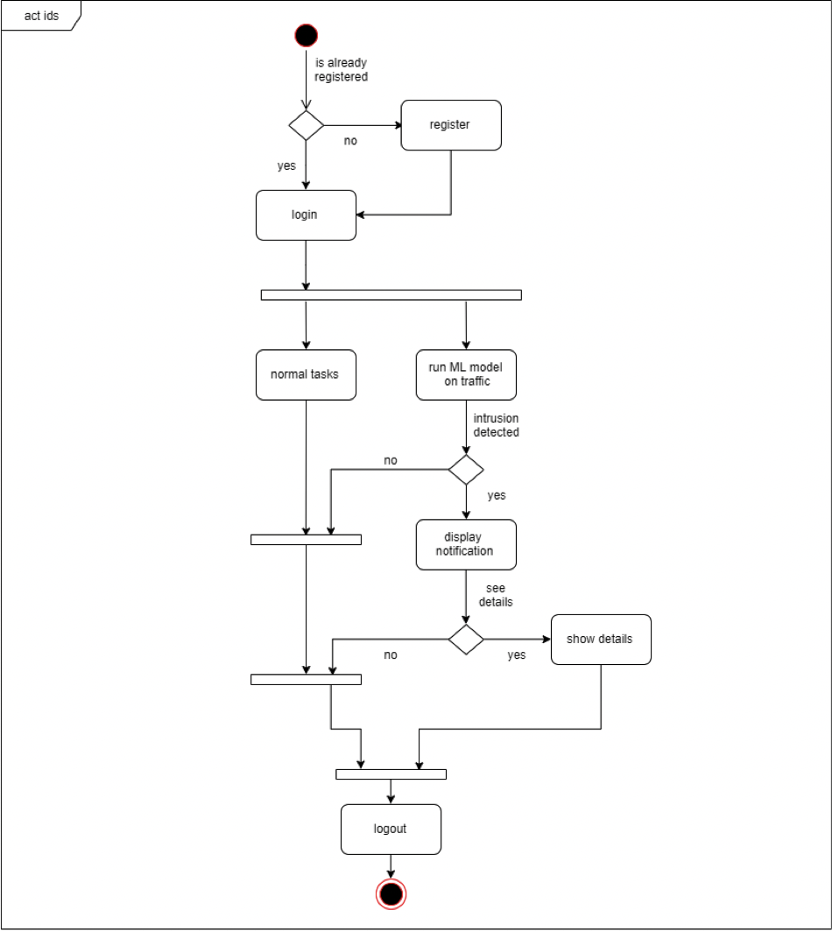

**Figure 3.2: Activity Diagram**

**3.6 Architecture Diagram**

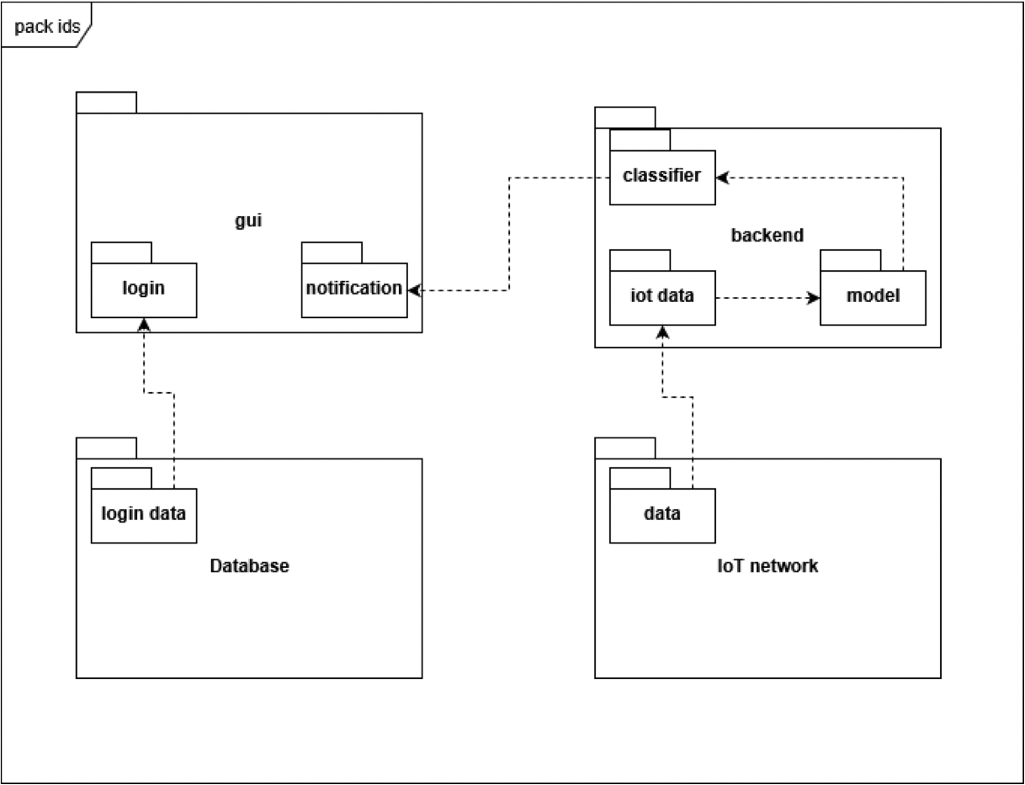

**Figure 3.3: Package Diagram**

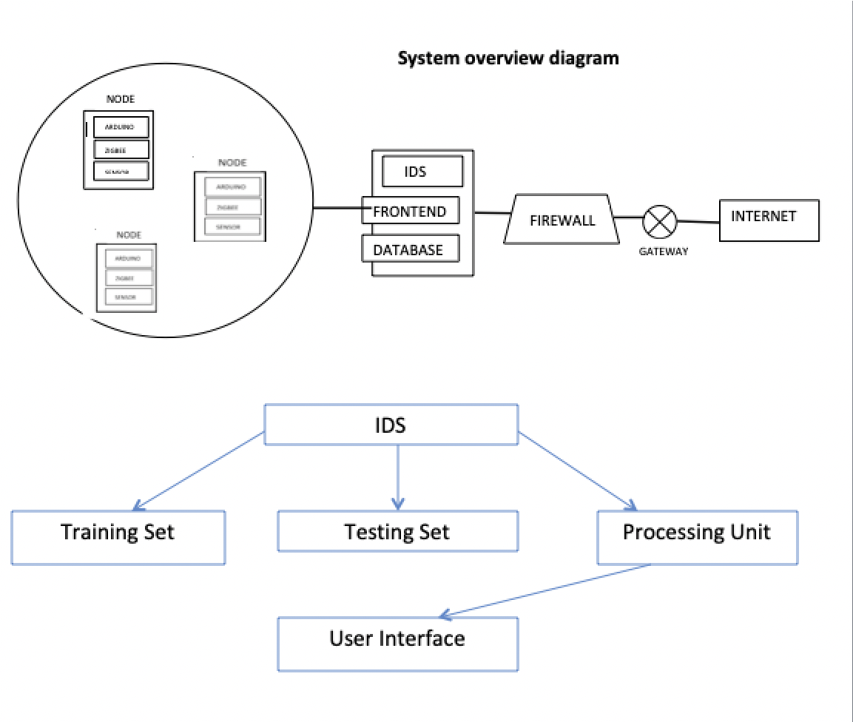

**Figure 3.4: System Overview Diagram**

**3.7 Class Diagrams**

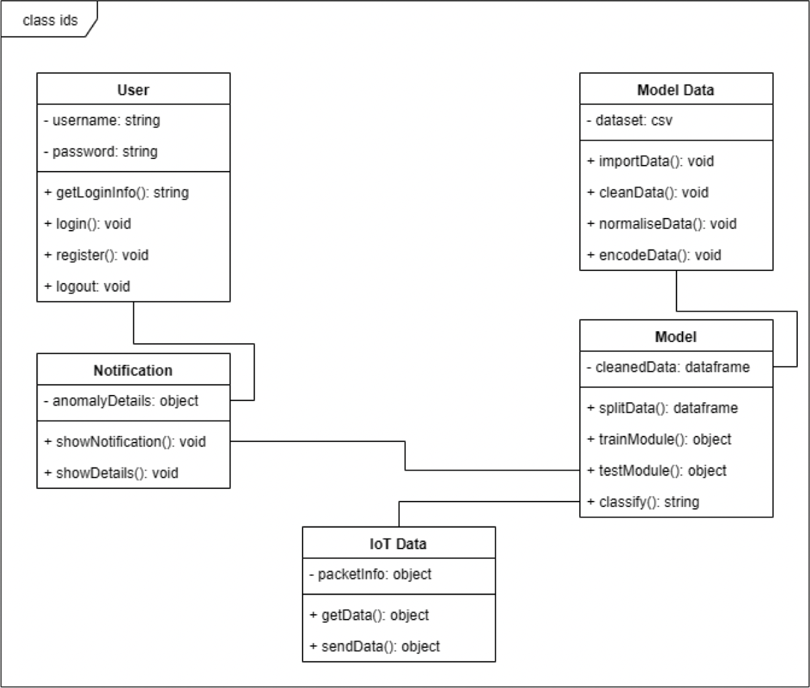

**Figure 3.5: Class Diagram**

**3.8 Sequence Diagrams**

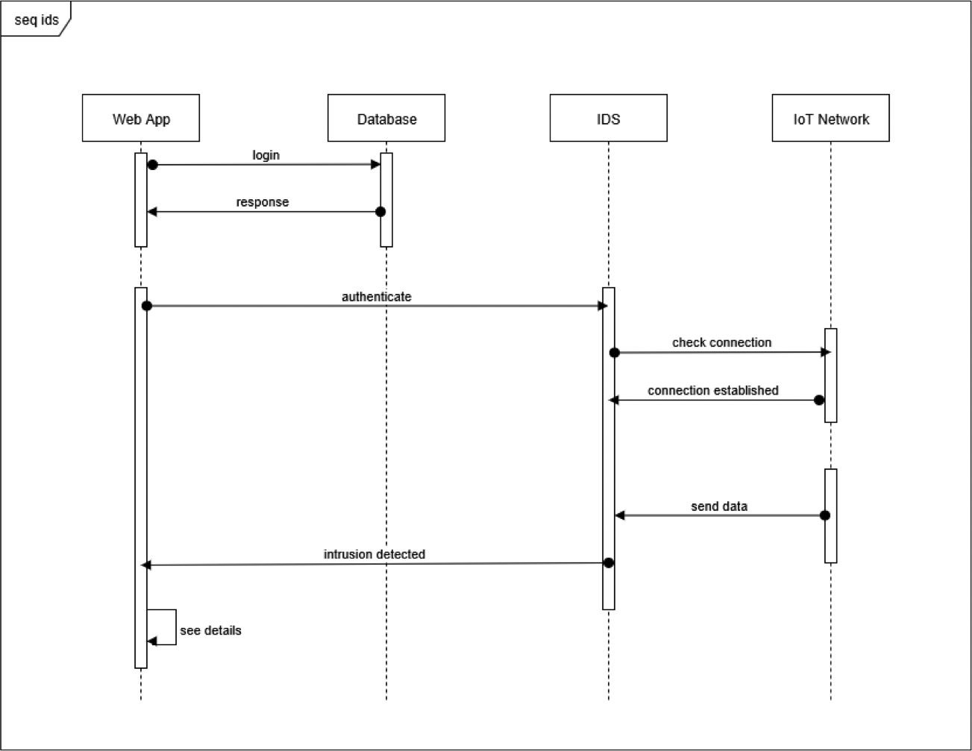

**Figure 3.6: Sequence Diagram**

**3.9 State Transition Diagrams**

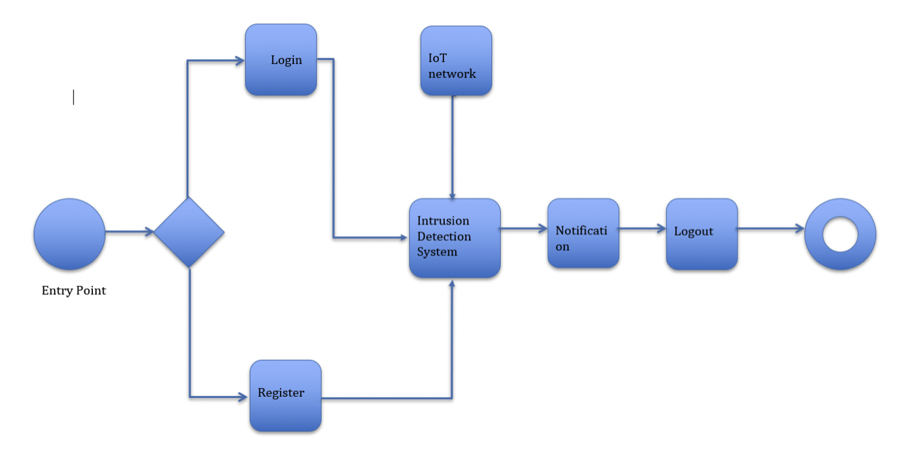

**Figure 3.7: State Transition Diagram**

**3.10 Deployment Diagrams**

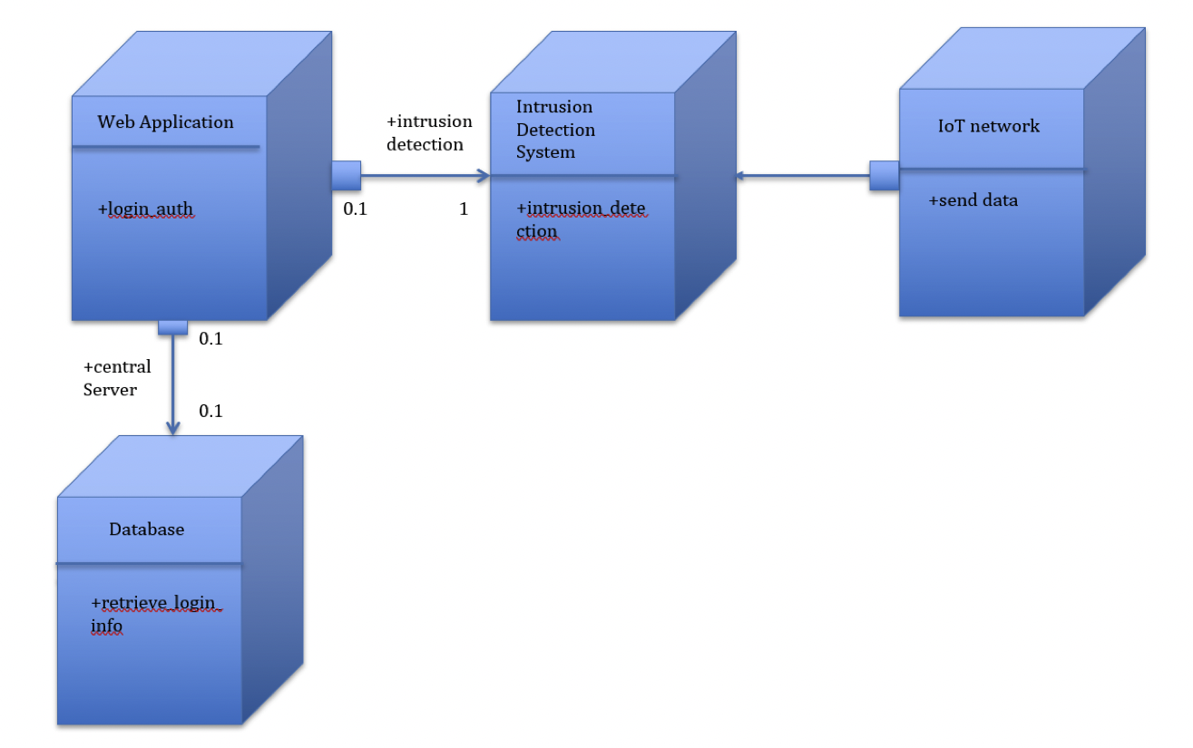

**Figure 3.8: Deployment Diagram**

**Chapter 4**

**Testing**

**4.1 Unit Testing**

**Table 4.1: Unit Testing 1**

|  |  |
| --- | --- |
|  |  |
| Title | Login and Authentication check |
|  |  |
| Test Item | Username, Password,Data packets |
|  |  |
| Input Specification | Test Item containing alphanumeric characters |
|  |  |
| Description | Specified details of Login/Register are entered and stored in database |
|  |
|  |
|  |  |
| Expected Results | Entry for Test Item is created in Database. |
|  |  |
|  |  |

|  |  |
| --- | --- |
|  | **Table 4.1: Unit Testing 2** |
| Title | Network Connection Check |
|  |  |
| Test Item | IOT devices,zigbee adapter |
|  |  |
| Input Specification | Test Item containing alphanumeric characters |
|  |  |
| Description | Zigbee protocol is used for connection,communication and sending the sensed data to base station |
|  |
|  |
|  |  |
| Expected Results | Data sensed is sent to the server. |
|  |  |
|  |  |

|  |  |
| --- | --- |
|  | **Table 4.1: Unit Testing 3** |
|  |  |
| Title | Intrusion Detection System processing check |
|  |  |
| Test Item | Sensed based data of specified sensor |
|  |  |
| Input Specification | Test item containing various ongoing intrusions on IOT network |
|  |
|  |
|  |  |
| Description | Intrusion detection data is used to detect malicious attacks on the IOT network and ignore normal behavior of the system |
|  |  |
|  |  |
|  |  |
| Expected Results | Category of the attack is determined |
|  |  |
|  | c |

**Table 4.1: Unit Testing 4**

|  |  |
| --- | --- |
|  |  |
| Title | Notification Check |
|  |  |
| Test Item | Notification page of web application(GUI) |
|  |  |
| Input Specification | Test Item containing processed data |
|  |  |
| Description | Alert only for abnormal behavior of the system |
|  |
|  |
|  |  |
| Expected Results | Alert to the user on the notification page if malicious attacks are detected |
|  |  |
|  |  |

**4.2 Integration Testing**

**Table 4.5: Integration Testing 1**

|  |  |
| --- | --- |
|  |  |
| Title | Intrusion Detection System |
|  |  |
| Description |  |
| Web Application is used to provide an interface between the network connection and the frontend |
|  |
|  |  |
| Test Steps | Run the program for detection of any intrusion on the IOT network |
|  |  |
| Expected Results | Detect the category of an attack |
|  |
|  |
|  |  |
|  |  |

**Table 4.6: Integration Testing 2**

|  |  |
| --- | --- |
|  |  |
| Title | Web Application. |
|  |  |
| Description |  |
| Web Application is used to provide an interface between the frontend and the user |
|  |
|  |  |
| Test Steps | Run the application program |
|  |  |
| Expected Results | Notification on the web page of if any abnormal behavior of the attack is detected |
|  |
|  |
|  |  |
|  |  |
|  |  |

**4.3 Acceptance Testing**

**Table 4.7: Acceptance Testing 1**

|  |  |
| --- | --- |
| Title | Sensed Availability data |
| Description | Ultrasonic sensor and temperature sensor are used to sense data and is processed to gather sensed availability data in the database |
| Expected Output | Sensed Availability data is sent to the base station using the zigbee protocol |
|  |  |

**Table 4.8: Acceptance Testing 2**

|  |  |
| --- | --- |
|  |  |
|  |  |
| Title | Performance |
|  |  |
| Description | The time required to transfer data from IOT devices to base station should be as little as possible and the time between the occurrence and detection of the attack should be minimum |
|  |
|  |
|  |  |
|  | Real time functioning of the system is achieved |
| Expected Output |  |
|  |  |
|  |  |
|  |  |